**Classroom Activity: Counter UI using functional component**

**Code:**

File Name: src/App.js

import React, { useState } from 'react';

import './App.css';

function App() {

  // Declare a new state variable, which we'll call "count"

  const [count, setCount] = useState(0);

  return (

    <div>

      <p>You clicked {count} times</p>

      <button onClick={() => setCount(count + 1)}>

        +

      </button>

      <button onClick={() => setCount(count - 1)}>

        -

      </button>

    </div>

  );

}

export default App;

File Name: src/App.css

|  |
| --- |
| .App {    text-align: center;  }  /* Center the counter in the middle of the page */  body {    display: flex;    justify-content: center;    align-items: center;    height: 100vh;    margin: 0;    font-family: Arial, sans-serif;    background-color: #f5f5f5;  }  /* Style for the main container */  div {    text-align: center;    background: white;    padding: 20px;    border-radius: 8px;    box-shadow: 0 0 10px rgba(0, 0, 0, 0.1);  }  /* Style for the heading */  h1 {    font-size: 4rem;    margin: 20px 0;    color: #333;  }  /* Style for the buttons */  button {    font-size: 2rem;    margin: 5px;    padding: 10px 20px;    border: none;    border-radius: 5px;    cursor: pointer;    background-color: #007bff;    color: white;    transition: background-color 0.3s;  }  /* Hover effect for buttons */  button:hover {    background-color: #0056b3;  } |

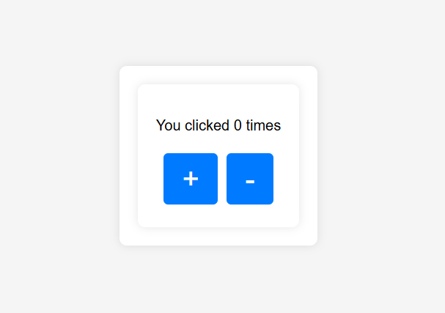**OUTPUT**

Figure: Output Screenshot 1

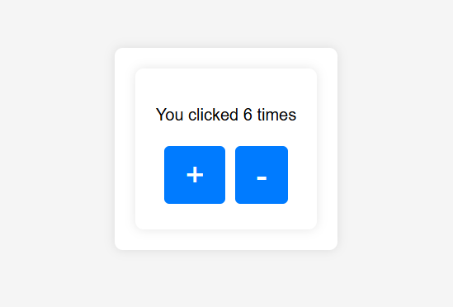

Figure: Output Screenshot 2

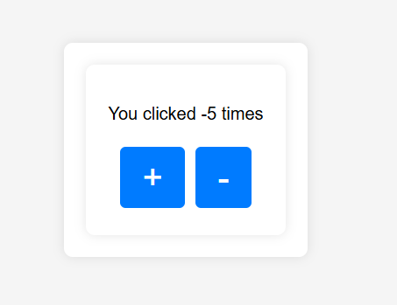

Figure: Output Screenshot 3

**Execution Steps:**

* Write the above code in App.js File
* Go to VS Code terminal
* Execute following command to run the program: npm start
* This will open your default browser and navigate to http://localhost:3000, where you will see your new React application running.